Institute of Technology

Tallaght

:

Chromatography and Measurement Systems

## ***Internal Examiners***

## Dr. Denise Egan.

## Dr. Eugene Hickey

## ***External Examiners***

Dr. David Page

**Day**

**Date**

**Time**

**Instructions to Candidates**

**Answer question one (compulsory) in Section A and one question from Section B and one question from Section C.**

**Total questions to be answered is three.**

**All questions are worth equal marks (100).**

**Total marks = 300**

### Section A- Dr. E. Hickey

# **Question 1 (compulsory)**

**Section B – Dr. D. Egan**

**Question 2.**

Answer all parts:

1. Outline the basis by which solute molecules are separated using gel filtration (also called size exclusion Chromatography), and specify the order of elution.
2. Give the mathematical formula used to calculate N, the Number of theoretical Plates, and define each term used.
3. Outline how you would prepare at least 350 ml solution of paracetamol at a concentration of 1.500 mg/ml. In your answer include the weight of paracetamol required, along with the glassware that you would use.
4. In the context of chromatography, explain what is meant by the term Column Selectivity. Use diagrams where appropriate to illustrate your answer.
5. Briefly explain the basis by which solutes separate using an ion exchange column, and outline how solutes that are bound to the stationary phase can subsequently be release for detection.
6. List three detectors used in GC and give an example of the type of solute that each type can detect.
7. Define the term pyrolysis.
8. What is the main role of the column oven as used in GC, and briefly describe how it is selected.
9. List the four properties of a column oven, as used in HPLC analysis.
10. Outline how you would prepare 100 ml of a 1.5 % (w/v) solution of paracetamol. In your answer include the weight of paracetamol required

**(10x10 = 100 marks)**

**Section C - Dr. D. Egan**

**Question 3**

Answer all parts:

1. Give a brief account of an experiment you would carry out in order to track the performance of a given HPLC column over time, and the data which would indicate that the column was no longer suitable for use.

**(20 marks)**

1. You as an analyst have been asked to prepare a 250 ml solution of paracetamol at a concentration of 0.055 M (molecular weight = 295). In your answer include the weight of paracetamol required, along with the glassware that you would use.
2. **marks)**
3. Give a detailed account of Reverse Phase Chromatography (RPC), as used in High Pressure Liquid Chromatography (HPLC). Use diagrams as appropriate to illustrate your answer.

**(60 marks)**

**Question 4**

Answer all parts:

1. In HPLC, gradient elution offers an alternative to isocratic elution. Give a detailed account of both isocratic and gradient elution. In your answer clearly indicate two scenario’s, where the separation seen with isocratic elution could be improved by the use of gradient elution.

**(35 marks)**

1. You as an analyst have been asked to dilute a 0.1 mg/ml solution of caffeine to prepare 10 ml of a series of five standards at each of the following concentrations: 0, 2.5, 5.0, 7.5, and 100 g/ml. In your answer specify the dilution factor required for each solution, and the glassware required throughout. **(25 marks)**
2. Using the chromatogram shown in Figure 1 below, answer all of the following :
   * + 1. Manually determine the retention time of p=Xylene and m-Xylene. Note that the chart speed was 10 mm/min.
       2. Manually determine the peak height of *p*=Xylene and *m*-Xylen.
       3. Comment on the chromatography associated with the separation of *p*=Xylene and *m*-Xylen.
       4. Give an account of three ways in which the separation of *p*=Xylene and *m*-Xylen could be improved.

Figure 1.

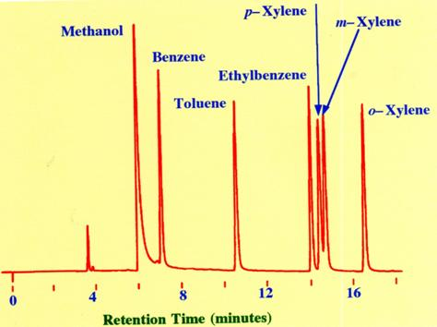

**(4x10 = 40 marks)**